Bahria University,

Karachi Campus



LAB EXPERIMENT NO. _11_

LIST OF TASKS

|  |  |
| --- | --- |
| TASK NO | OBJECTIVE |
| Task 1 | Create a doubly link list and perform following operation.   * 1. Insert at beginning ().   2. Insert at end ().   3. Insert node at given data ().   4. Delete from start ()   5. Delete from end ()   6. Delete node of given data (). |
| Task 2 |  |
| Task 3 | N/A |
| Task 4 | N/A |
| Task 5 | N/A |
| Task 6 | N/A |
| Task 7 | N/A |
| Task 8 | N/A |

Submitted On:

__12/06/2020__

(Date: DD/MM

**Task No. 1**Create a doubly link list and perform following operation.

1. Insert at beginning ().
2. Insert at end ().
3. Insert node at given data ().
4. Delete from start ()
5. Delete from end ()

Delete node of given data ().

**Coding:**

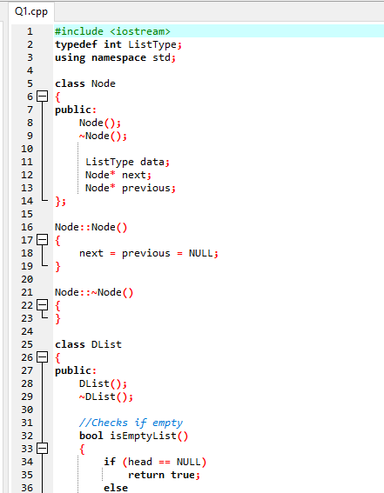

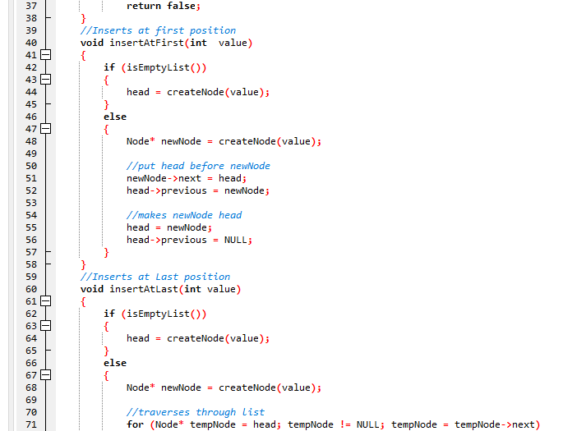 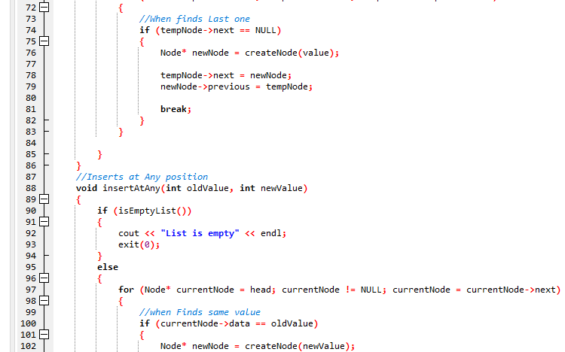

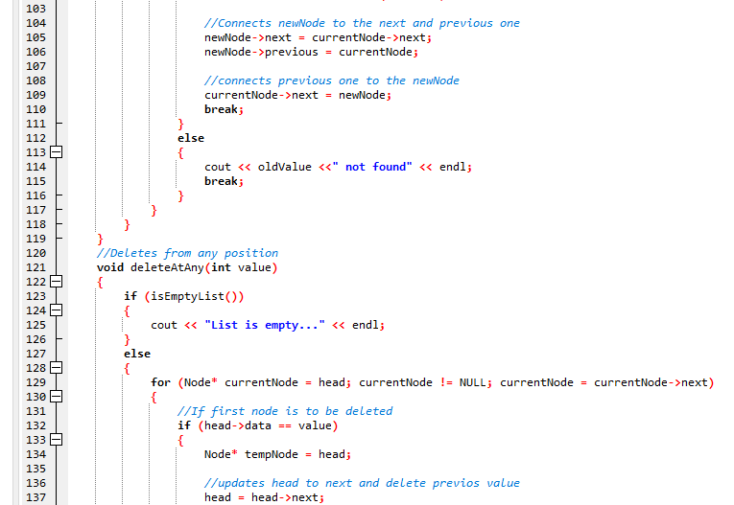 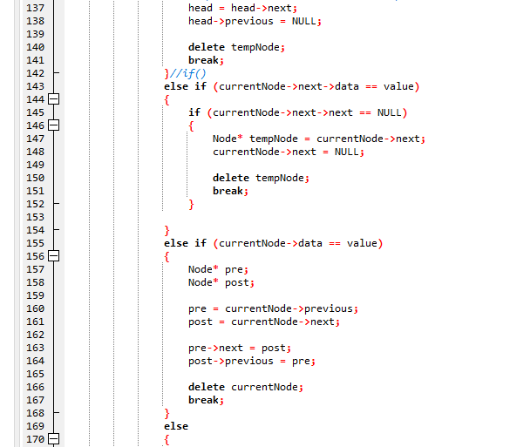

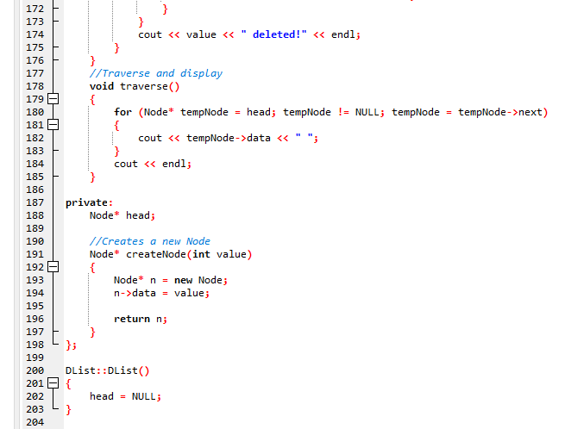 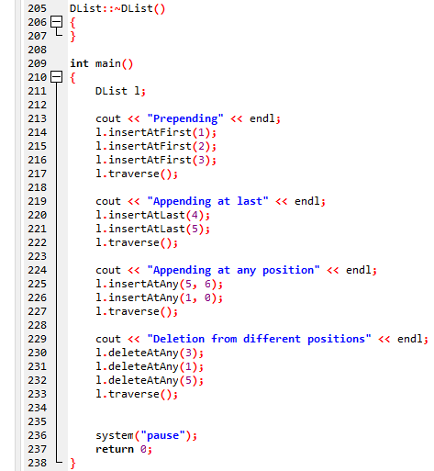

**Output:**

